**A PRELIMINARY REPORT ON**

**AI in Automobile Industry**

SUBMITTED TO THE SAVITRIBAI PHULE PUNE UNIVERSITY, PUNE

IN THE PARTIAL FULFILLMENT OF THE REQUIREMENTS

FOR THE ACADEMIC

OF

**THIRD YEAR OF COMPUTER ENGINEERING**

**SUBMITTED BY**

**Student Name : Ojus P. Jaiswal Roll No. : TACO19108**

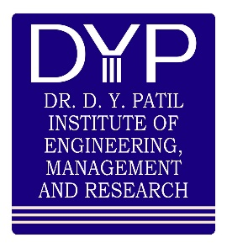

## DEPARTMENT OF COMPUTER ENGINEERING

## DR. D.Y. PATIL INSTITUTE OF ENGINEERING, MANAGEMENT &

## RESEARCH

**AKURDI, PUNE 411044**

**SAVITRIBAI PHULE PUNE UNIVERSITY**

AY 2021 -2022



**CERTIFICATE**

This is to certify that the Seminar report entitles

**AI in Automobile Industry**

Submitted by

**Student Name : Ojus P. Jaiswal Roll No. : TACO19108**

**is a bonafide student of this institute and the work has been carried out by them under the supervision of Mrs. P. P. Shevatekar and it is approved for the partial fulfillment of the requirement of Savitribai Phule Pune University, for the award of the third-year degree of Computer Engineering.**

**Mrs. P. P. Shevatekar** **Mrs. P. P. Shevatekar**

Guide Head,

Department of Computer Engineering Department of Computer Engineering

Place : Pune

Date :

# ABSTRACT

Vehicles have become one of the most well-known transportation modes. An ever-increasing number of vehicles happen with various Man-made intelligence-based frameworks. To make this standard transportation more agreeable, proficient, and more secure for individuals to use, man-made reasoning advancements are applied in vehicles, making them a lot smarter and more intelligent. Computer-based intelligence advances at present have effectively been used to a great extent in vehicles to further develop vehicle safety, efficient use, and solace. By enabling the AI advances in vehicles, vehicles are currently fit for doing considerably more than the vehicles previously. Presently the most recent advancements in AI strategies offer bunches of new freedoms for Intelligent Transportation Systems (ITS). The new utilization of those AI strategies in vehicles prompts the vehicle better assessing the surroundings and giving a convenient and relatively safe and comfortable driving experience to drivers. In any case, even though the present AI applications in vehicles are currently thorough, there are still plenty of enhancements that can be finished by individuals to make the vehicles become 100 percent safe and smart.

In this paper, three fundamental utilizations of AI in vehicles including the AI for Vehicle-to-Everything(V2X), AI in the vehicle control system, and AI diagnostic device for vehicles will be shown. The current technical issues while applying AI in V2X and difficulties for all the Artificial intelligence applications are needed to be overcome. This paper additionally examines the future expectations for the improvement of the use of AI in vehicles.

**Keywords:** Artificial Intelligence, Vehicles, Applications.

**ACKNOWLEDGEMENT**

First and foremost, I would like to thank to my guide of this seminar, **Mrs. P. P. Shevatekar** for the valuable guidance and advice. She inspired us greatly to work in this seminar. Her willingness to motivate us contributed tremendously to our seminar work. I also would like to thank her for showing me some examples that related to the topic of my seminar.

Apart from our efforts, the success of any seminar depends largely on the encouragement and guidelines of many others. So, we take this opportunity to express my gratitude to **Mrs. P. P. Shevatekar**, Head of Department of Computer Engineering, Dr. D Y Patil Institute of Engineering, Management and Research, Akurdi who have been instrumental in the successful completion of this seminar work.

The guidance and support received from all the members who contributed and who are contributing to this seminar work, was vital for the success of the seminar. I am grateful for their constant support and help.

Ojus P. Jaiswal

(T.E. CCOMPUTER ENGG.)

# Table of Contents

|  |  |  |
| --- | --- | --- |
| **Sr.**  **No.** | **Content** | **Page**  **No.** |
| 1 | Introduction | 6 |
|  | 1.1 Introduction | 6 |
|  | 1.2 Problem Statement | 7 |
|  | 1.3 Objectives | 7 |
| 2 | Literature Review | 8 |
| 3 | Details of design/technology/Analytical Work with Diagrams and Experimental Study | 9 |
| 4 | Discussions and Conclusions | 17 |
| 5 | References | 18 |
| 6 | Annexure | 20 |
|  | 1. Plagiarism Check report | 20 |
|  | 1. Seminar Log Book | 21 |

**CHAPTER 1: INTRODUCTION**

## INTRODUCTION

Artificial intelligence (AI) is a technology that uses data and algorithms to mimic human decision-making and reasoning abilities. Financial services, information and communication technology (ICT), life science, retail, healthcare, industrial manufacturing, automotive, oil and gas, and chemicals are among the industries where an algorithm is being used to assist the system understand and solve a problem on its own.

Self-driving automobiles have been a figment of the imagination for the past 50 years or more, only appearing in science fiction. However, huge breakthroughs in the last decade have paved the way for it to become a reality. The possibility of a real self-driving, fully autonomous vehicle has shifted from "possible" to "inevitable." This inevitability has arisen as a result of two major factors/innovations over the years: massive volumes of data available in the cloud and the rise of increasing computational power.

Currently, AI technologies are mostly used in automobiles to improve vehicle safety, efficiency, and comfort. Automobiles are now capable of considerably more than they were in the past, thanks to the advancement of AI technology in vehicles. The most recent advances in AI approaches now provide a plethora of new possibilities for Intelligent Transportation Systems (ITS). The new application of those AI approaches in automobiles allows the vehicle to better estimate the surrounding environment, resulting in a more convenient, safe, and comfortable driving experience for the driver. Even though today's AI applications in automobiles are extensive, humans may still make a lot of enhancements to make the vehicles 100% safe and intelligent.

Benefits of AI in Transportation :

* + 1. Public Safety
    2. Autonomous Vehicles
    3. Better Planning and Decision Making
    4. Pedestrian Safety

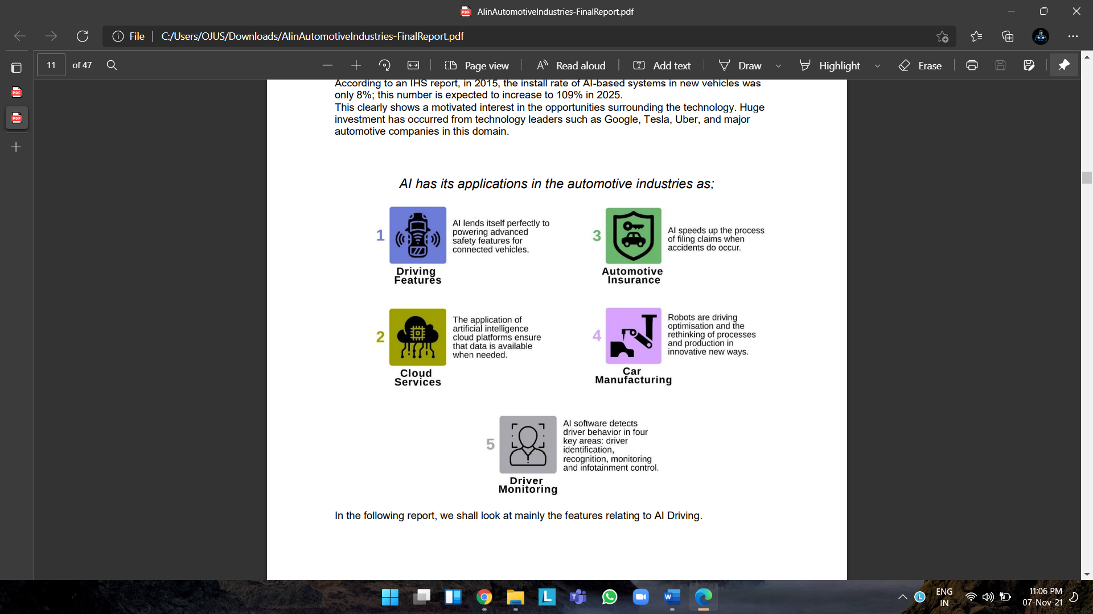

## PROBLEM STATEMENT

Analyzing the drawbacks of current AI Applications in Automobiles and finding solutions to such drawbacks.

## OBJECTIVES

* + 1. Analysis of AI Applications in Automobiles.
    2. Future Expectations of AI Applications in Automobiles.

**CHAPTER 2: LITERATURE REVIEW**

## Literature review

|  |  |  |  |  |  |  |
| --- | --- | --- | --- | --- | --- | --- |
| **Sr No** | **Paper Title** | **Journal Name, Year** | **Objective** | **Methodology/Technology/Algorithm used** | **Dataset/Features** | **Conclusion** |
| 1 | Analysis on the Applications of AI in Vehicles and the Expectation for Future | IEEE Xplore, 2020 | Understanding uses of AI in Automobile Industry | Artificial Intelligence, Machine Learning, IOT | 1) Enables Autonomous driving  2) Increases driver safety | AI can be used to increase comfort, convenience and security of vehicles. |
| 2 | An Overview of Artificial Intelligence in Automobile Industry -A Case Study on Tesla Cars | ResearchGate, 2021 | To study the concept of introducing AI and NLP (natural language processing) in automobile industry | Artificial Intelligence, Machine Learning, IOT, Chabot, Virtual Assistant, NLP (natural language processing) | 1) Personal voice assistant  2) AI Chatbot | AI can be used to create more efficient vehicles. |
| 3 | Impact of AI on the Automobile Industry in the U.S. | SSRN Papers,  2021 | To demonstrate the importance of Artificial Intelligence (AI) implementation in the automobile industry | Artificial Intelligence, Machine Learning, IOT | 1) Supply chains are impacted by AI | AI make a drastic impact on companies and entire supply chains around the world. |

# CHAPTER 3: Details of design/technology/Analytical Work with Diagrams and Experimental Study

## 3.1 Details of design/technology/Analytical Work with Diagrams

## 3.1.1 AI in V2X Application

## 

## Vehicle-to-Everything (V2X), a system that allows automobiles to communicate with moving portions of the traffic system around them, when integrated with AI, can enable novel applications in Vehicular Ad-hoc NETworks (VANETs). It may, for example, predict and manage real-time traffic flow, store data in cars, and carry facilities autonomously. Dedicated Short Range Communication (DSRC) is one technology that enables V2X. VANET, a network that does not require any infrastructure for automobiles, is enabled by DSRC. This has become a critical aspect in ensuring security in remote places and undeveloped areas. Common Awareness Messages (CAM) and Basic Safety Messages (BSM) are the messages delivered by DSRC cars to VANET. Cellular-V2X is another technology that can enable V2X and is based on Long-Term Evolution (LTE) cellular connectivity. LTE is a higher-credit, higher-bandwidth technology that requires modification before being deployed in the V2X. Because the vehicle can obtain information from moving sections of the road, such as driving safety status, road safety index, and road visibility conditions, these two technologies employed in the V2X system make the car significantly safer and efficient.

## Furthermore, the navigation of driverless cars is the most anticipated capability of V2X. Another important component in ensuring ITS is Autonomous Intersection Management (AIM). To detect autonomous and linked cars, a cooperative motion planning system known as Near Optimal Online Motion Planning (NOOP) was developed. This multi-vehicle motion planning situation becomes a centralized and mathematically optimal question. Because of the high dimensionality of the collision-avoidance restrictions and the nonlinearity of the vehicle's movement, numerically solving the mathematic question is difficult. In this case, a novel strategy called two-stage planning and optimization can be used to solve the problem. Vehicles are obliged to form a standard formation before entering the traffic intersection in the first phase. Vehicles then cross the intersection in the second phase. The obstacles in the optimal problem are considerably reduced when one hard and numerous demission mathematic question is divided into two independent optimal questions.

## As a result, the AIM's real-time performance was attained.

## V2X: The Basics of Connected Vehicle Technology | Intellias Blog

## 

## 

## 3.1.2 The Application of AI in Vehicle Control System

## The use of AI in vehicles can also be used to control the vehicle's velocity based on the driver's driving habits. The environment is linked to automobiles during follow-up driving that correlate to the driver's driving tendencies. The distance between the vehicle and the vehicle ahead of it, as well as the relative speed and position, are all measured. The driver's sense of driving will be used to calculate the hazard index, which will be based on the measured vehicle surroundings and moving condition. To be more specific, the distance between the automobiles and the automobiles in front is computed while the automobile in front decelerates is sensed by the automobile itself, in order to prevent a collision.

## A specific sensor will measure the danger index, which will subsequently be sent to a display device. The display unit or special sensor will then use the danger index to determine whether to accelerate or decelerate the vehicle, and will issue a command to the driver to manage the brake and accelerator automatically. In this situation, the use of AI in the vehicle control system has once again greatly improved driving safety.

## 

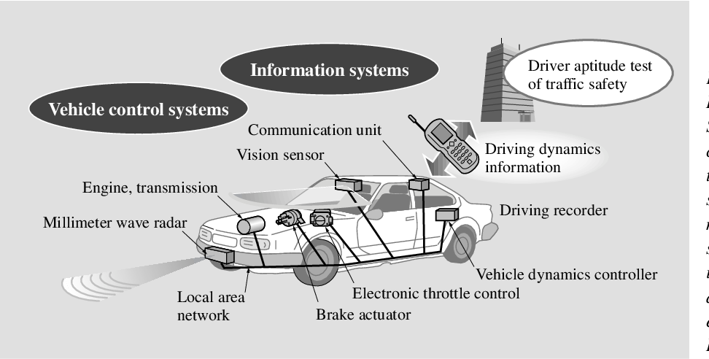

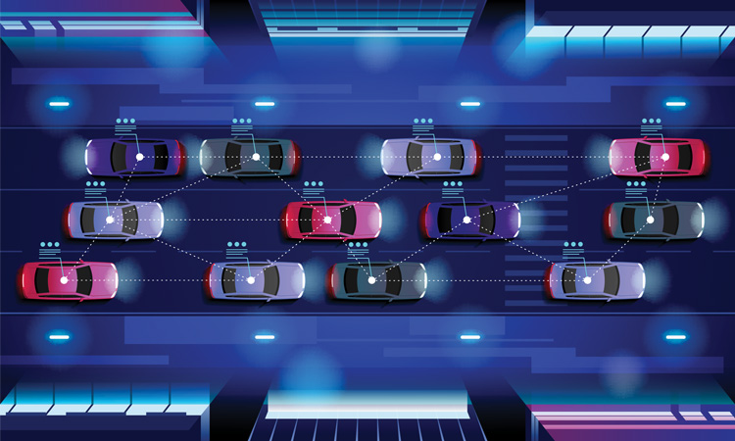

## 3.1.3 AI Diagnostic Device for Vehicles

## 

## An artificial intelligence diagnosis device is offered, which can be utilized to centrally manage a vehicle's electrical and control equipment utilizing a separate diagnostic central processing unit to diagnose malfunction in real-time and transmit the results to the driver. An electronic time and alarm control system diagnostic unit, a junction box diagnostic unit, the diagnostic central processing unit, and the output unit are all part of the AI diagnostic equipment. The electronic time and alarm control system diagnostic unit is used to diagnose the electronic time of the electronic systems of the control car and the state of the alarm control system; the junction box diagnostic unit is used to diagnose various fuses and the state of the relay; the diagnostic central processing unit is used to receive and analyze the diagnostic signals output from the electronic time and alarm control system diagnostic unit, the junction box diagnostic unit, and the diagnostic central processing unit; the diagnostic central processing unit is used to receive and analyze the diagnostic signals output from the electronic time and alarm control. The diagnostic central processing unit's signal is received by the output unit, which then reports the abnormal situation to the driver. The driver is then informed of the normal or abnormal state of the electrical equipment so that he or she may readily determine which part of the vehicle is malfunctioning while driving. As a result, the vehicle can be simply fixed in a short period of time for a reasonable cost. When the car breaks down, swift action might also be performed. Furthermore, because the car's failure is checked automatically every day, accidents caused by improper maintenance can be avoided.

## 

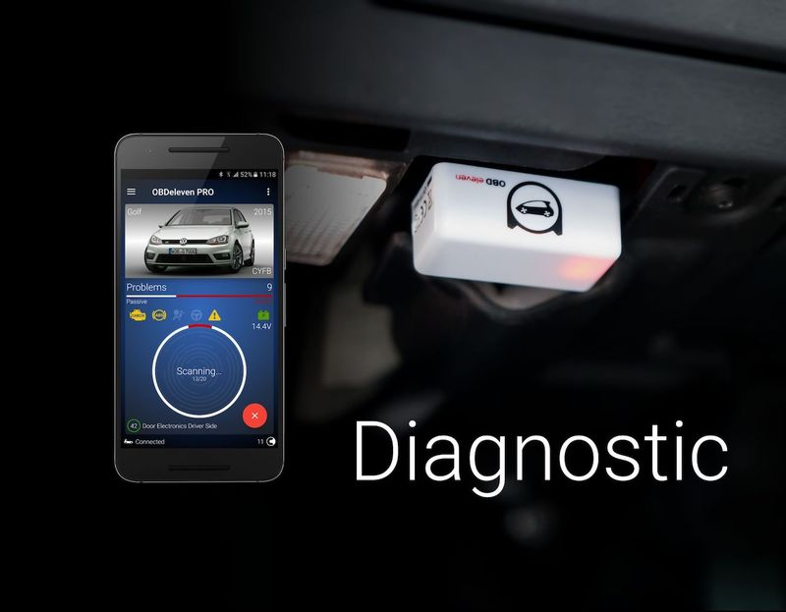

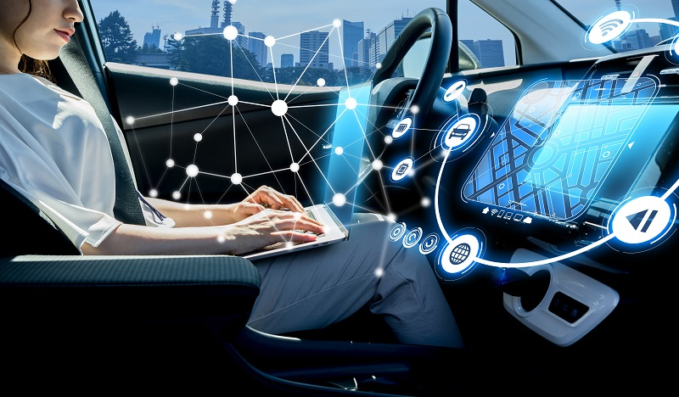

## 3.2 Experimental Study

3.2.1 AI in V2X Application

Vehicle to Everything (V2X) is a vehicular communication system that allows information to be transferred from a vehicle to moving sections of the traffic system that may have an impact on the vehicle. The primary goal of V2X technology is to increase road safety, energy efficiency, and traffic efficiency.

Information from vehicle sensors and other sources passes across high-bandwidth, high-reliability links in a V2X communication system, allowing it to communicate with other automobiles, infrastructure such as parking spots and traffic signals, and smartphone-tossing people.

The technology improves the driver's awareness of potential threats by sharing information such as speed with other entities around the car. This helps to lessen the severity of injuries, road accident fatalities, and collisions with other vehicles.

Additionally, the technology improves traffic efficiency by alerting vehicles to impending traffic, offering other routes to avoid traffic, and locating vacant parking spaces.

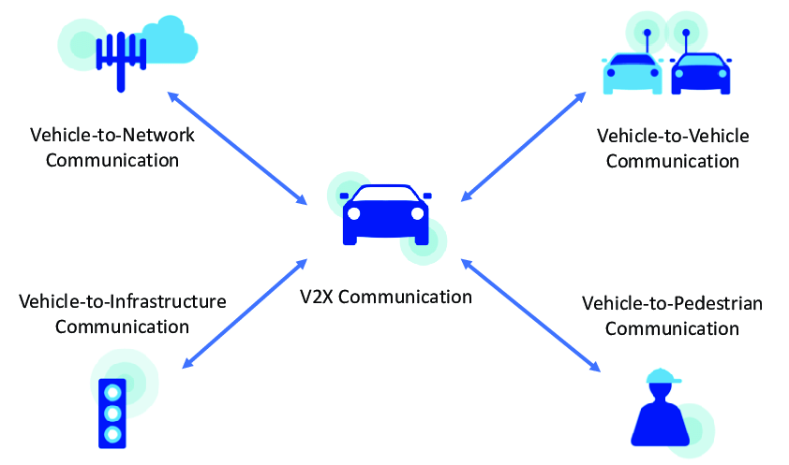

## 3.2.2 The Application of AI in Vehicle Control System

In theory, a full vehicle control system consists of a single ECU that manages all aspects of the vehicle. A complete vehicle control system is depicted in the diagram. Separate ECUs, rather than a single control unit, are employed in practise and can communicate with one another.

The benefits of central control are most noticeable in the primary areas of inputs and outputs. Consider all of the inputs required to operate each of the three systems below on the input side.

• Ignition system  
• Fuel system  
• Transmission system.  
Even with only three possible domains of vehicle control, it is clear that there are many common requirements. One central control system has the ability to reduce wiring complexity while enhancing control possibilities. This is, in fact, the outputs' advantage.

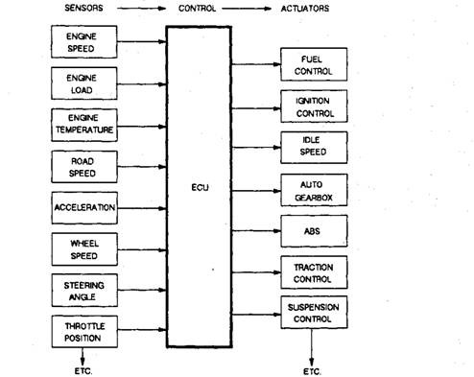

## 3.2.3 AI Diagnostic Device for Vehicles

New diagnostic approaches are required for autonomous trucks on the road where the driver is not present. A machine lacks some abilities that a driver possesses. The usage of machine learning as a method was examined in this thesis. The fundamental goal of detecting anomalies in wheel configurations was converted into a more explicit problem statement. The machine learning model was utilized to detect erroneous wheel settings in particular. SVM, LDA, and logistic regression were the three algorithms employed. Overall, the classifier makes accurate predictions, indicating that machine learning may be used to diagnose autonomous vehicles.

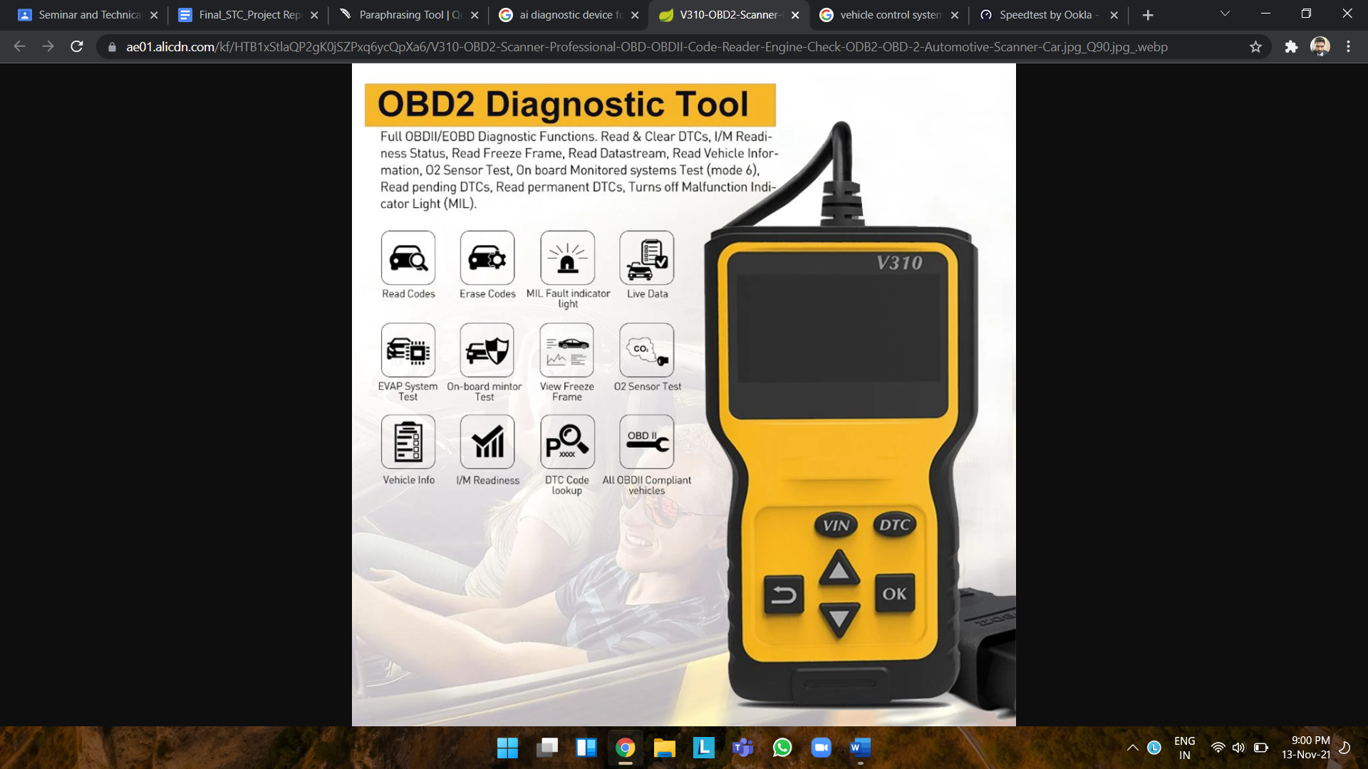

# CHAPTER 4: Discussions and Conclusions

## 4.1 Conclusion

From the above, we can conclude that AI in the automotive industry is an evolutionary step

for getting things done more effectively and efficiently. It is user-friendly as well as

environmental-friendly and ultimately, will lead to sustainable development. It is a great

way to save the exploitation of nature and human resources available in our surroundings.

# CHAPTER 5: References

[1] <https://www.researchgate.net/publication/349298066_An_Overview_of_Artificial_Intelligence_in_Automobile_Industry_-A_Case_Study_on_Tesla_Cars>

[2] <https://papers.ssrn.com/sol3/papers.cfm?abstract_id=3841426>

[3] <https://iopscience.iop.org/article/10.1088/1742-6596/1402/6/066081/meta>

[4] <https://www.futurebridge.com/industry/perspectives-mobility/artificial-intelligence-reshaping-the-automotive-industry/>

[5] <http://www.ijirset.com/upload/2018/may/224_Artificial.pdf>

[6] <https://www.acea.auto/files/ACEA_Position_Paper-Artificial_Intelligence_in_the_automotive_industry.pdf>

[7] <https://arxiv.org/pdf/1709.01989>

[8] <https://www.sagesoftware.co.in/blogs/impact-of-artificial-intelligence-on-the-automotive-industry-3/>

[9] <https://corporatefinanceinstitute.com/resources/knowledge/other/vehicle-to-everything-v2x/>

[10] <https://www.globenewswire.com/news-release/2020/04/16/2017153/0/en/AI-in-Automotive-2020-Research-Report-An-Insight-Into-How-AI-is-Likely-to-Open-Up-New-Opportunities-for-OEMs-in-the-Near-Future.html>

[11] <https://corporatefinanceinstitute.com/resources/knowledge/other/vehicle-to-everything-v2x/>

[12] <https://www.trendhunter.com/trends/diagnostics-device>

[13] <https://www.automotive-iq.com/autonomous-drive/articles/advanced-automotive-diagnostics-systems-from-diagnostics-to-prognostics>

[14] <https://www.intelligenttransport.com/transport-news/120436/ai-safety-system/>

[15] <https://intellias.com/v2x-basics-connected-vehicle-technology/>

[16] <https://www.semanticscholar.org/paper/Vehicle-Control-and-Information-Systems-for-Safe-Kuroda-Takano/426cb319ecab240e4aaaec0f415ce8b608e700c6>

[17] <https://what-when-how.com/automobile/complete-vehicle-control-systems-automobile/>

[18] <https://www.diva-portal.org/smash/get/diva2:1215462/FULLTEXT01.pdf>

[19] <https://www.google.com/url?sa=i&url=https%3A%2F%2Fwww.aliexpress.com%2Fitem%2F4000015755598.html&psig=AOvVaw3kKZZZK5yv617oMRmhAL7W&ust=1636903518962000&source=images&cd=vfe&ved=0CAsQjRxqFwoTCNjOq4HTlfQCFQAAAAAdAAAAABAY>

# Plagiarism Check Report

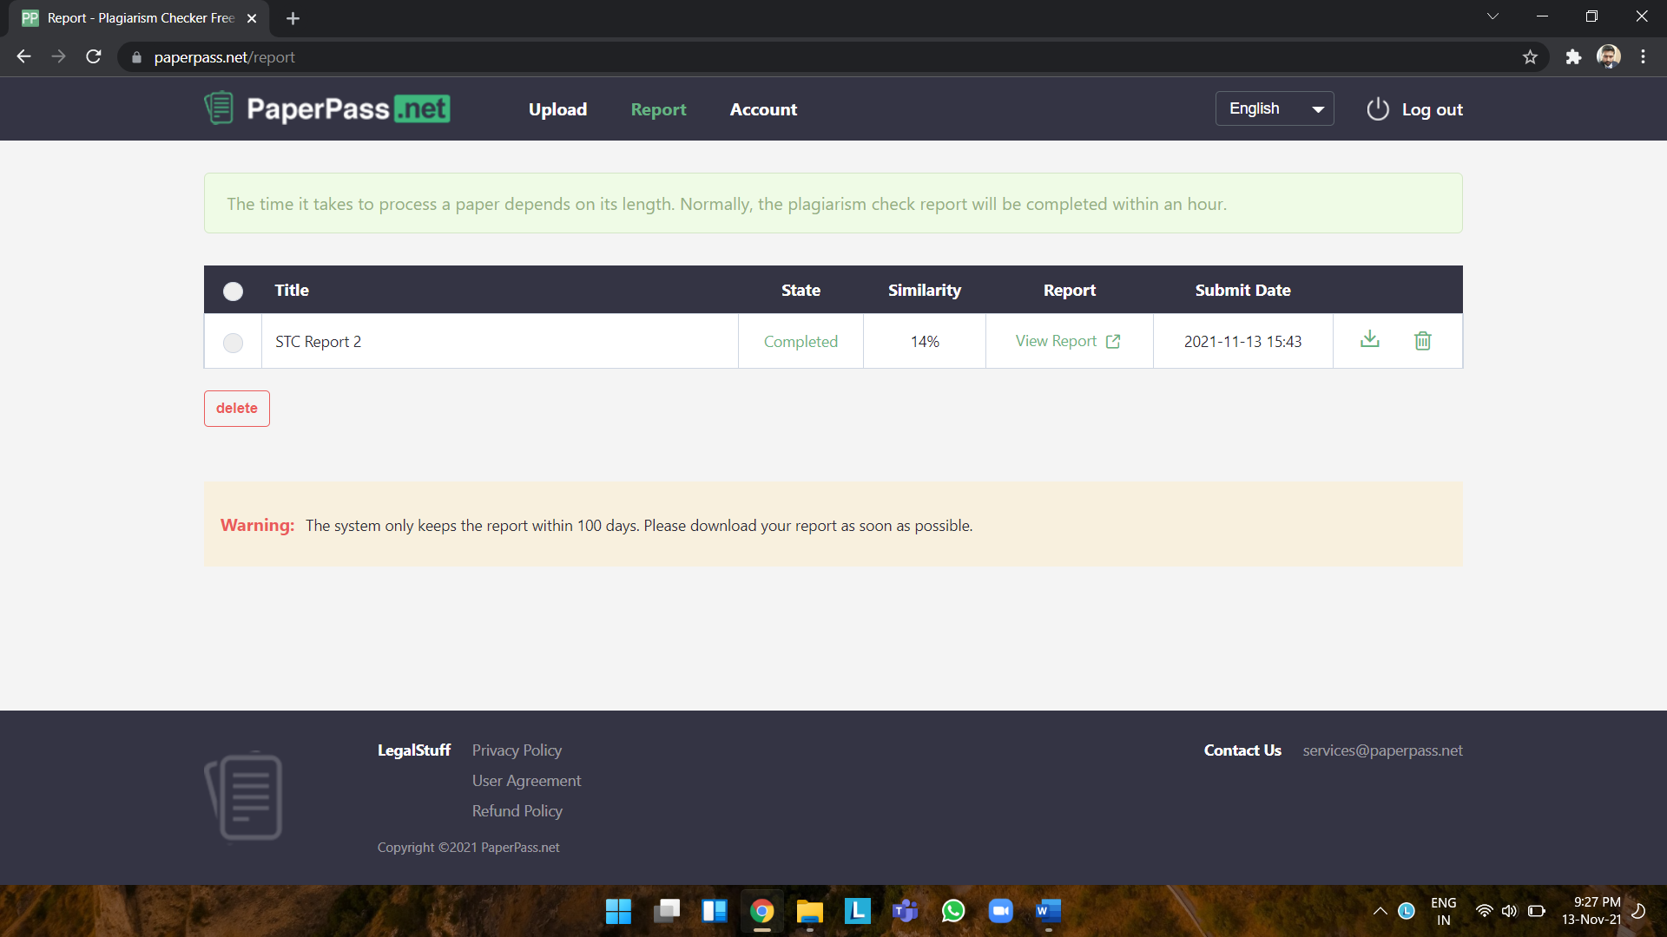

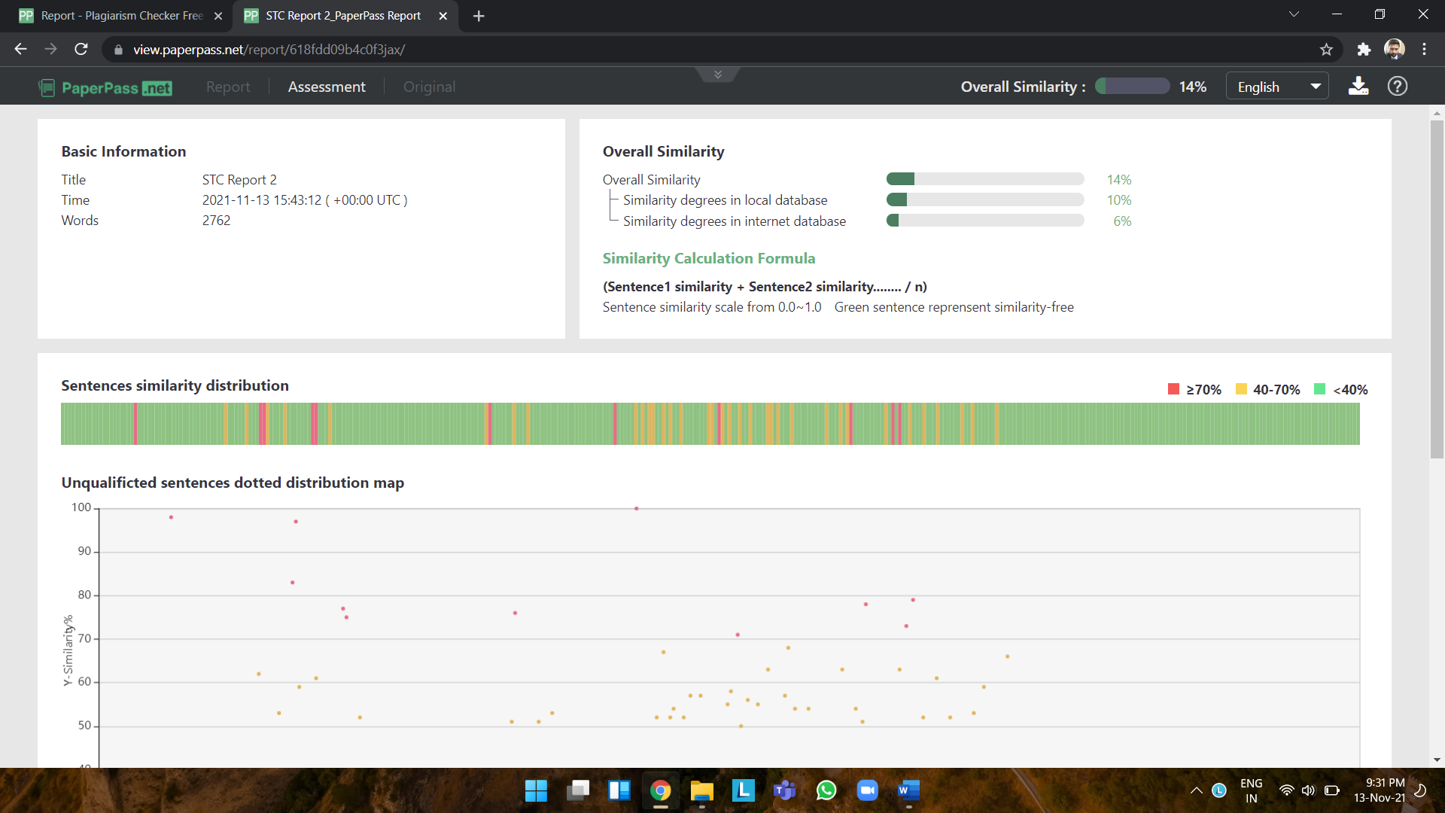

# Seminar Log Book

# Record of Seminar Review with Guides

|  |  |  |  |
| --- | --- | --- | --- |
| **Sr. No.** | **Date** | **Details of Discussion/ Remark** | **Signature of Guide** |
| 1. | 30/08/2021 | Title Submission | Mrs. P. P. Shevatekar |
| 2. | 17/09/2021 | Base Paper Submission | Mrs. P. P. Shevatekar |
| 3. | 17/09/2021 | Synopsis formation | Mrs. P. P. Shevatekar |
| 4. | 23/09/2021 | PPT checking and | Mrs. P. P. Shevatekar |
| 5. | 14/10/2021 | Seminar Report Checking | Mrs. P. P. Shevatekar |
| 6. | 29/10/2021 | Seminar Report finalization | Mrs. P. P. Shevatekar |
| 7. | 18/11/2021 | Final PPT Submission | Mrs. P. P. Shevatekar |